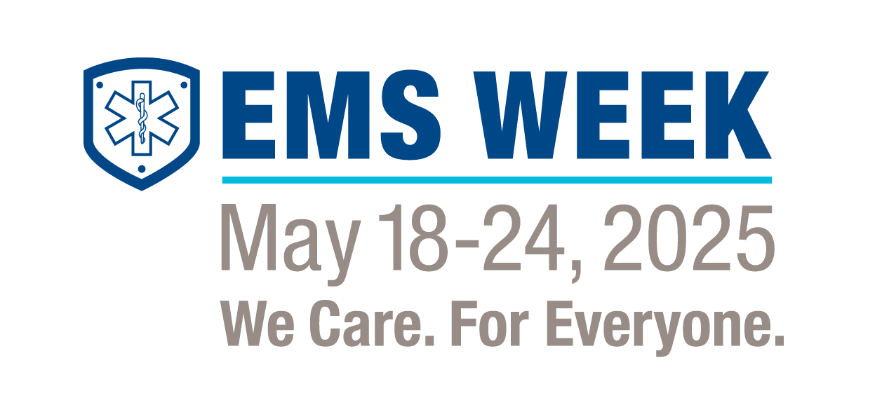

EMS Week Proclamation

To designate the Week of May 18-24, 2025, as Emergency Medical Services Week (EMS Week).

WHEREAS, emergency medical services is a vital public service; and

WHEREAS, the members of emergency medical services teams are ready to provide lifesaving care to those in need 24 hours a day, seven days a week; and

WHEREAS, access to quality emergency care dramatically improves the survival and recovery rate of those who experience sudden illness or injury; and

WHEREAS, emergency medical services fills healthcare gaps by providing important, out-of-hospital care, including preventative medicine, follow-up care, and access to telemedicine; and

WHEREAS, the emergency medical services system consists of first responders, emergency medical technicians, paramedics, emergency medical dispatchers, firefighters, police officers, educators, administrators, pre-hospital nurses, emergency nurses, emergency physicians, trained members of the public, and other out of hospital medical care providers; and

WHEREAS, the members of emergency medical services teams, whether career or volunteer, engage in thousands of hours of specialized training and continuing education to enhance their lifesaving skills; and

WHEREAS, it is appropriate to recognize the value and the accomplishments of emergency medical services providers by designating the Emergency Medical Services Week; now

*THEREFORE, I [name, title, city, state] in recognition of this event do hereby proclaim the week of May 18 - 24, 2025, as*

**EMERGENCY MEDICAL SERVICES WEEK**

The 51st anniversary of EMS Week theme is ***EMS WEEK:* We Care. For Everyone**. I encourage the community to observe this week with appropriate programs, ceremonies, and activities in honor of the EMS profession and the essential service it provides.

Name and Title of Official